KIDZ Connection of VISD
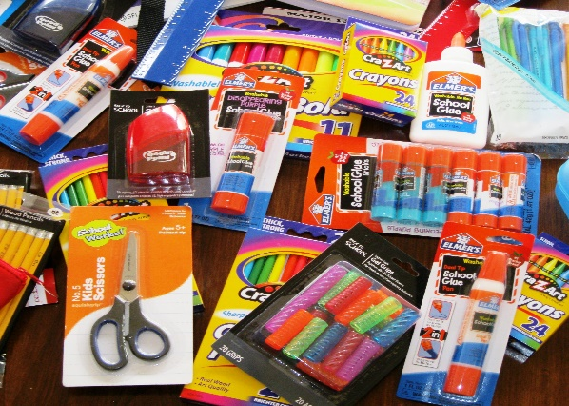
School Supplies List

Watercolor paints
Blunt-tip scissors
Glue sticks
Composition notebooks (100+ pages)
3-ring pencil pouches
Folders with brads

Please deliver to The Nave Museum by July 30th at 8 PM or before to any of the participating drop-box locations below:
Casa de Luna
Victoria Art League
NutriFuel
Moonshine Drinkery
Symbiotik Comics, Cards, and Collectibles

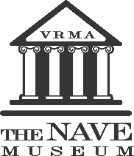
Thank you for helping support VISD students!

